Supplemental Materials

Pilot Study 1
The aim of Pilot Study 1 was to examine attitudes toward behaviors that either conform to or deviate from prescriptive views of aging (PVoA) in the workplace. The study specifically focused on age-related norms relevant to older employees, defined here as individuals aged 50 to 65 who are currently employed. We investigated two prominent types of PVoA in the work context: active aging, which emphasizes continued engagement, productivity, and motivation at work; and altruistic disengagement, which involves gradually stepping back from professional responsibilities and shifting attention toward private life. We tested the following hypotheses:
H1: Evaluative consequences of norm adherence/violation – Older employees who violate PVoA in the work context will be evaluated less positively than those who adhere to them.
H2: Norm dependence of evaluative consequences – Evaluative consequences of norm violation will vary depending on which PVoA is violated. Specifically, for older employees below retirement age, violating the active aging norm will lead to more negative evaluations than violating the disengagement norm, which is expected to have little or no evaluative impact.
H3: Criterion dependence – Evaluations of older employees may vary depending on the evaluative dimension (warmth vs. social status).
Method
Participants
The initial sample consisted of 89 middle-aged adults (aged 50–65 years; Mage = 56.20 years, 50.56% women), all of whom were native German speakers and currently employed. Fifteen participants were excluded due to (1) careless responding, indicated by homogeneous answers on the dependent variables (n = 13), or (2) extreme outlier values on the dependent variables (n = 2). The final sample included 74 adults aged 50 to 65 years, of whom 52.70% were women. Background characteristics of both included and excluded participants are presented in Table 1. An a priori power analysis indicated that a minimum of 84 participants was required to detect a small effect (f = .10) with sufficient power (1–β = .80). We assumed a small effect due to a lack of previous research testing the same hypotheses. Participants were recruited either directly by the research team (n = 39) or via Prolific (n = 50). Those recruited through Prolific received monetary compensation, while those recruited by the research team participated on a voluntary basis. Data collection took place between February and April 2025.
Design
Study 1 employed a 2 (PVoA Type: active aging vs. altruistic disengagement in the work domain) × 2 (Target Behavior: adherence vs. violation) × 2 (Evaluative Dimension: warmth vs. social status) within-subjects design.
Measures and Materials
Target Profiles
The targets were male older employee protagonists who described themselves as displaying behavior that either adhered to or violated the norms of altruistic disengagement or of active aging in the work domain. We constructed target profiles that varied along several dimensions: age (ranging from 57 to 60 years), name (reflecting common German names from mid 1960s), and occupation (sound technician, HR manager, business consultant, and laboratory technician). There was one profile for each age norm (i.e., altruistic disengagement and active aging) and behavior type (i.e., adherence and violation), resulting in a total of four distinct target profiles evaluated by participants (see Appendices SA for a detailed description of the target profiles).
Target Profile Evaluation
Participants’ evaluations of the target profiles were measured using two separate attitude scales, reflecting distinct components of attitude that serve as reliable dimensions of social judgment: warmth and perceived social status (Fiske et al., 2007).
Feeling Thermometer. Given its ease of use and demonstrated reliability and validity (Alwin, 1997), warmth ratings were collected using a feeling thermometer. Participants were asked to indicate how they felt toward the presented target by adjusting a slider resembling a colorful thermometer, ranging from 1 (cold) to 11 (warm).
Social Status Ladder. Perceived social status was assessed using an adapted version of the MacArthur Scale of Subjective Social Status (Adler et al., 2000; Robertson & Weiss, 2017). Participants were shown an image of a ladder and were told the following: “Think of this ladder as representing where people stand in society. At the top of the ladder are the people who are best off—who are most respected in society and looked up to in society. At the bottom of the ladder are the people who are the worst off—who are least respected and looked down to in society. Where would you place (target’s name) on this ladder?” Participants were asked to indicate the target’s perceived social status by selecting a position on the ladder ranging from 1 (low status) to 11 (high status).
Procedure
Participants completed the study online using a personal computer via the SoSci Survey platform (https://www.soscisurvey.de/). At the beginning of the study, they received a brief introduction outlining the study goals and the technical requirements and were then asked to provide written informed consent.
Following this, participants completed a short sociodemographic questionnaire. They then answered the PVoA in the work domain items. Before proceeding to the target profile evaluations, participants read the following instruction: “You will now be presented with several short descriptions of older employees, defined as individuals between 50 and 65 years of age. Please take your time to read each one carefully. After each description, we will ask you to provide a brief assessment based on the information given. There are no right or wrong answers – we are interested in your personal opinion.” Each target profile appeared on a separate page and was followed by two evaluation measures: the feeling thermometer and the social status ladder. The order of the profiles was randomized across participants.
After evaluating all profiles, participants were asked whether they had previously taken part in studies on similar topics. The study concluded with a debriefing, which clarified that all target profiles were fictional.
Analytic Strategy
A 2 x 2 x 2 repeated measures ANOVA using the three factors of the design (PVoA Type, Target Behavior, and Evaluative Dimension, within) was carried out. Partial eta-squared (η²ₚ) was reported as a measure of effect size, using the effectsize package (Ben-Schachar et al., 2020). For statistically significant main effects and interactions, estimated marginal means were obtained using the emmeans package (Lenth, 2025), and pairwise comparisons were conducted to examine to significant main effects and interactions.
Results
The analysis revealed significant main effects of PVoA Type, F(1, 73) = 4.43, p = .039, partial η² = .040, Target Behavior, F(1, 73) = 16.11, p < .001, partial η² = .362, and Evaluative Dimension, F(1, 73) = 23.01, p < .001, partial η² = .240 (see Table S2). Follow-up comparisons indicated that target profiles describing active aging behaviors (M = 8.33, SE = 0.10) were more positively evaluated than target profiles describing altruistic disengagement behaviors (M = 8.12, SE = 0.10). As hypothesized (H1), targets who violated one of the aging norms were evaluated less positively (M = 8.05, SE = 0.10) than targets who adhered to them (M = 8.41, SE = 0.10). Overall, warmth ratings (M = 8.53, SE = 0.11) were higher than social status ratings (M = 7.92, SE = 0.11).
Confirming H2, a significant PVoA Type by Target Behavior interaction emerged, F(1, 73) = 77.12, p < .001, partial η² = .181. To explore the significant interaction between PVoA Type and Target Behavior, pairwise comparisons of estimated marginal means were conducted. For the activation-related target profiles, adherence behaviors were rated more positively (M = 9.05, SE = 0.12) than violation behaviors (M = 7.61, SE = 0.13), t(73) = 9.92, p < .001. In contrast, for the disengagement target profiles, this effect was reversed, with violation behaviors receiving higher ratings (M = 8.48, SE = 0.13) than adherence behaviors (M = 7.76, SE = 0.13), t(73) = –4.53, p < .001. These findings suggest that the evaluation of adherence vs. violation behavior is strongly influenced by the type of PVoA: Under activation norms, adherence is viewed more positively, whereas under disengagement norms, violations are evaluated more favorably in the work context.
In line with H3, the interaction between PVoA Type and Target Behavior was further qualified by Evaluative Dimension, F(1, 73) = 41.43, p < .001, partial η² = .514. This three-way interaction indicates that the effect of PVoA Type and Target Behavior on evaluations differed depending on whether participants rated social status or warmth. An examination of the three-way interaction revealed that the two-way interaction between PVoA Type and Target Behavior was primarily driven by social status ratings (see Figure S1). Specifically, in the activation PVoA condition, adherence behaviors were rated significantly higher in status (M = 9.05, SE = 0.13) than violation behaviors (M = 6.93, SE = 0.16), t(73) = 11.44, p < .001. In contrast, in the disengagement PVoA condition, violation behaviors were rated higher in status (M = 8.72, SE = 0.13) than adherence behaviors (M = 6.97, SE = 0.18), t(73) = –8.30, p < .001. showing a clear crossover pattern.
For warmth ratings, a similar pattern was observed in the activation condition, with adherence rated higher (M = 9.04, SE = 0.18) than violation (M = 8.30, SE = 0.17), t(73) = 3.08, p = .003, however, this difference was much less pronounced than for social status. In the disengagement condition, adherence (M = 8.55, SE = 0.18) and violation (M = 8.24, SE = 0.22) did not differ significantly regarding warmth, t(73) = 1.23, p = .223. These results indicate that the effect of PVoA Type on evaluations of adherence vs. violation behaviors depends on the type of evaluation, emerging strongly in judgments of social status, but much less so in judgments of warmth.
Discussion
Replicating prior work showing that violation of age-based expectations is punished (e.g., North & Fiske, 2013), older workers who violated prescriptive violations of age (PVoA) in the work domain were perceived less positively than those who adhered to age norms, such that intentions to retire before the mandatory age were sanctioned.
Pilot Study 1 further showed that for pre-retirement older workers, the dominant age norm is active aging, i.e., emphasizing continued workforce engagement, while altruistic disengagement (the expectation to step back for younger generations) is not yet salient. Accordingly, violating altruistic disengagement (e.g., remaining in demanding roles or working beyond mandatory retirement) was viewed even more favorably than adhering to it, suggesting ongoing professional engagement remains socially valued at this life stage. Perceived social status, rather than warmth, was the more relevant evaluative dimension here, consistent with the idea that actively maintaining productivity counters stereotypes of decline as traditional status markers begin to lose salience in later adulthood (Weiss & Kuball, 2025).

Pilot Study 2
As in Pilot Study 1, the aim of Pilot Study 2 was to investigate attitudes toward behaviors that either align with or diverge from PVoA. Whereas Pilot Study 1 focused broadly on age norms relevant to older employees, this second pilot study examined perceptions of individuals beyond the mandatory retirement age (i.e., 65 years). Given that Pilot Study 1 found no evidence for sanctions regarding the norm of altruistic disengagement before reaching retirement age, we decided to focus specifically on this norm in Pilot Study 2. In Pilot Study 2, we investigated the following hypotheses:
H1: Evaluative Consequences of Norm Adherence/Violation – Older adults who have passed the official retirement age and violate the norm of altruistic disengagement in the work domain will be evaluated less positively than those who adhere to it.
H2: Criterion dependence – Evaluations of older adults may vary depending on the evaluative dimension (warmth vs. social status).
Method
Participants
The initial sample comprised 375 adults (60 – 87 years, Mage = 69.10 years, 47.2% women) who were German native speakers. We excluded 42 participants due to (1) not completing the study (n = 10), (2) providing meaningless responses in a secondary task not relevant to the current results (n = 20; e.g., yes, no, -), and (3) 12 participants due to careless responding (i.e., homogeneous responses in the dependent variables). The final sample comprised 333 adults aged 60 to 87 years (61.90% were 66 years or older, 48.35% were women, and 70.57% were retired). Table S3 displays background information of included and excluded participants. An a priori power analysis indicated a minimum of 328 participants to discover a small effect (f = .10) with sufficient power (1–β = .80). Again, we assumed a small effect due to a lack of previous research testing the same hypotheses. Participants received monetary compensation and were recruited via Bilendi (bilendi.de). Data were collected in July 2024.
Design
Study 2 employed a 2 (Target Behavior: adherence to vs. violation of the disengagement norm) × 2 (Evaluative Dimension: warmth vs. social status) × 2 (Target Gender: female vs. male) within-subjects design.
Measures and Materials
Target Profiles
The targets were older adult protagonists beyond retirement age (i.e., 65 years) who described themselves as displaying behavior that either adhered to or violated the norm of altruistic disengagement in the work domain. As in Pilot Study 1, we constructed target profiles that varied along several dimensions: age (ranging from 66 to 69 years), name (reflecting common German names from the 1950s to 1960s), gender (male or female), and occupation (bank clerk, editor, lawyer, and salesperson). There were two profiles for each behavior type (i.e., adherence to and violation of the norm of altruistic disengagement), one per gender, resulting in a total of four distinct target profiles evaluated by participants (see Appendices SB and E for a detailed description of the target profiles).
To ensure that target evaluations were not confounded by the specific content of any single profile, we used a counterbalanced design involving the four core occupational scenarios: bank clerk, editor, lawyer, and salesperson. Each occupation was paired with a target behavior condition, either adherence or violation of altruistic disengagement, and was represented across both genders. This resulted in four base profiles (two adherence, two violation), which were then mirrored across gender to create a total of eight unique target profiles: The adherence profiles (bank clerk and editor) were each used once for a female target and once for a male target. The violation profiles (lawyer and salesperson) followed the same structure. For example, the profile of a retiring bank clerk (adherence) appeared once as a female target (FA1) and once as a male target (MA2). Similarly, the profile of a non-retiring lawyer (violation) was presented once as female (FV2) and once as male (MV1). This approach allowed for full counterbalancing of gender and behavior type, while keeping content comparable across conditions.
Together with each target profile, participants were presented with a facial portrait of an older adult and an audio recording by an older adult in the same age range as the depicted targets. In the recording, the older adults narrated the respective target profiles. The facial portraits were selected from the FACES database (Ebner et al., 2010). The four accompanying audio recordings—two by women and two by men—were produced by German native speakers approximately matching the age of their respective target profiles.
Target Profile Evaluation
As in Pilot Study 1, participants evaluated the target profiles using the Feeling Thermometer and the Social Status Ladder. The only difference was in the response scales: the Feeling Thermometer ranged from 1 (cold) to 100 (warm), while the Social Status Ladder ranged from 1 (low status) to 10 (high status). To ensure comparability between the two measures, the Feeling Thermometer scores were rescaled to a 1–10 range.
Procedure
As in Pilot Study 1, participants completed the study online via the platform SoSci Survey (https://www.soscisurvey.de/) using a personal computer and headphones. At the beginning, they received a brief introduction informing them about the technical requirements of the study. Participants were then asked to provide informed consent, which included a confirmation that they would not distribute any of the study materials, as required by the FACES database release agreement.
Following these introductory pages, sociodemographic data were collected. Participants then answered the Baseline Endorsement of Altruistic Disengagement items. Before proceeding to the target profile evaluation, participants read the following explanation: “Next, you will complete a part of the study in which we present brief descriptions of individuals. In this context, we asked several people over the age of 65 to introduce themselves and describe their current professional situation.” Participants were then instructed to put on their headphones and complete a short audio test to ensure their audio output was functioning properly. Each target profile was presented on a separate page, followed by two evaluation measures: the feeling thermometer and the social status ladder. The presentation order of the target profiles was determined by several factors. First, participants’ gender determined whether they saw the female or male target profiles first. Second, the order of target behavior (i.e., adherence vs. violation of the norm) was randomly assigned for the first set of profiles. The second set followed the same behavior order as the first. For example, a female participant would first view two female target profiles. Whether the adherer or violator appeared first was randomly determined. This order (e.g., adherer first, violator second) was then mirrored for the male profiles shown afterward. After evaluating all target profiles, participants were asked whether they had participated in any previous studies on related topics. The study concluded with a debriefing, which clarified that all target profiles were fictional.
Analytic Strategy
A 2 x 2 repeated measures ANOVA using the two factors of the design (Target Behavior and Evaluative Dimension, within) was carried out. Partial eta-squared (η²ₚ) was reported as a measure of effect size, using the effectsize package (Ben-Schachar et al., 2020). For statistically significant main effects and interactions, estimated marginal means were obtained using the emmeans package (Lenth, 2025), and pairwise comparisons were conducted to examine to significant main effects and interactions.
Results
The analysis revealed significant main effects of Target Behavior, F(1, 332) = 11.73, p < .001, partial η² = .034, and Evaluative Dimension, F(1, 332) = 7.79, p = .006, partial η² = .023, (see Table S4). Follow-up comparisons indicated that, as hypothesized in H1, targets who violated altruistic disengagement norms were evaluated less positively (M = 6.81, SE = 0.08) than targets who adhered to them (M = 7.15, SE = 0.08). Overall, social status ratings (M = 7.09, SE = 0.06) were higher than warmth ratings (M = 6.87, SE = 0.08).
In line with H2, a significant two-way interaction emerged between Target Behavior and Evaluative Dimension, F(1, 332) = 8.95, p = .003, partial η² = .026. This finding suggests that the participants’ evaluations depended not only on the target behavior but also on the dimension along which the target was evaluated (i.e., warmth vs. social status), as shown in Figure S2.
To explore the significant interaction between Target Behavior and Evaluative Dimension, pairwise comparisons of estimated marginal means were conducted. For warmth ratings, adherence behaviors were rated significantly more positively (M = 7.13, SE = 0.10) than violation (M = 6.61, SE = 0.11), t(332) = 3.84, p < .001. In contrast, for social status ratings, there was no difference between violation (M = 7.01, SE = 0.08) and adherence behaviors (M = 7.17, SE = 0.08), t(332) = 1.78, p = .076. These results indicate that the effect of Target Behavior, adherence vs. violation behaviors of older protagonist past retirement age, depended on the type of evaluation, emerging strongly in judgments of warmth, but not in judgments of social status.
Discussion
Pilot Study 2 showed that older adults past retirement age who violated altruistic disengagement norms were evaluated less positively than those who adhered to them, suggesting that working beyond retirement age is socially undesirable. Notably, whereas Pilot Study 1 identified social status as the central evaluative dimension for pre-retirement workers, Pilot Study 2 revealed that evaluative differences for post-retirement individuals emerged in warmth rather than status, thus indicating a shift in the basis of social evaluation across the life course.
Social role theory (Eagly & Wood, 2012) helps explain this pattern: as individuals transition from worker to retiree, they lose formal status, and warmth becomes a more central component of social value and identity. This aligns with the Stereotype Content Model (Fiske et al., 2002), which characterizes older adults as high in warmth but low in status. In non-work domains, warmth-related attributes such as generosity and mentorship become key sources of influence and social integration as formal status recedes.

References
Ben-Shachar M, Lüdecke D, & Makowski D (2020). effectsize: Estimation of effect size indices and standardized parameters. Journal of Open Source Software, 5(56), 2815. https://doi.org/10.21105/joss.02815
Eagly, A. H., & Wood, W. (2012). Social role theory. In P. A. M. Van Lange, A. W. Kruglanski, & E. T. Higgins (Eds.), Handbook of Theories of Social Psychology (pp. 458–476). Sage Publications Ltd. https://doi.org/10.4135/9781446249222.n49
Fiske, S. T., Cuddy, A. J. C., Glick, P., & Xu, J. (2002). A model of (often mixed) stereotype content: Competence and warmth respectively follow from perceived status and competition. Journal of Personality and Social Psychology, 82(6), 878–902. https://doi.org/10.1037/0022-3514.82.6.878
Lenth, R. (2025). emmeans: Estimated Marginal Means, aka Least-Squares Means. R package version 1.11.2-80003, https://rvlenth.github.io/emmeans/.
North, M. S., & Fiske, S. T. (2013). Act your (old) age: Prescriptive, ageist biases over succession, consumption, and identity. Personality and Social Psychology Bulletin, 39(6), 720–734. https://doi.org/10.1177/0146167213480043
Weiss, D., Kuball, T. (2025). Stepping up and stepping down: The dynamic nature of social status across the lifespan. Journal of Adult Development. https://doi.org/10.1007/s10804-025-09532-y
Tables

Table S1
Pilot Study 1: Background Information of Included and Excluded Participants
Characteristic | Excluded N = 15¹ | Included N = 74¹ | p-value²
Sex |  |  | 0.539
female | 6.00 (40.00%) | 39.00 (52.70%)
Age | 56.20 (4.20) | 56.20 (4.26) | 0.998
Education (years) |  |  | 0.573
10 years | 2.00 (13.33%) | 16.00 (21.62%)
< 10 years | 2.00 (13.33%) | 5.00 (6.76%)
> 10 years | 11.00 (73.33%) | 53.00 (71.62%)
Perceived Health | 3.87 (0.92) | 3.97 (0.72) | 0.677
Note. ¹n (%); Mean (SD).²Pearson's Chi-squared test; Welch Two Sample t-test

Table S2
Pilot Study 1: Mixed ANOVA Results for Warmth and Status Ratings by PVoA Type and Target Behavior
Effect | df | MSE | F | η²p | p-value
PVoA Type | 1, 73 | 1.47 | 4.43 * | 0.040 | .039
Target | 1, 73 | 1.18 | 16.11 *** | 0.362 | <.001
Dimension | 1, 73 | 2.43 | 23.01 *** | 0.240 | <.001
PVoA Type × Target | 1, 73 | 2.21 | 77.12 *** | 0.181 | <.001
PVoA Type × Dimension | 1, 73 | 1.02 | 0.54 | 0.057 | .466
Target × Dimension | 1, 73 | 1.40 | 3.01 | 0.007 | .087
PVoA Type × Target × Dimension | 1, 73 | 2.63 | 41.43 *** | 0.514 | <.001
Note. df=degrees of freedom; MSE=Mean Square Error; η²p = partial eta-squared.

Table S3
Pilot Study 2: Background Information of Included and Excluded Participants
Characteristic | Excluded N = 42¹ | Included N = 333¹ | p-value²
Sex |  |  | 0.276
female | 16 (38.10%) | 161 (48.35%)
Age | 66.21 (4.79) | 67.67 (5.23) | 0.071
Education (years) |  |  | 0.114
10 years | 16 (38.10%) | 135 (40.54%)
< 10 years | 10 (23.81%) | 41 (12.31%)
> 10 years | 16 (38.10%) | 157 (47.15%)
Occupation |  |  | 0.020
Retired | 26 (61.90%) | 235 (70.57%)
Working | 11 (26.19%) | 88 (26.43%)
Other | 5 (11.90%) | 10 (3.00%)
Perceived Health | 3.14 (0.93) | 3.40 (0.74) | 0.091
Note. ¹n (%); Mean (SD). ²Pearson's Chi-squared test; Welch Two Sample t-test

Table S4
Pilot Study 2: Mixed ANOVA Results for Warmth and Status Ratings by Target Behavior
Effect | df | MSE | F | η²p | p-value
Target | 1, 332 | 3.29 | 11.73 *** | 0.034 | <.001
Dimension | 1, 332 | 2.02 | 7.79 ** | 0.023 | .006
Target × Dimension | 1, 332 | 1.14 | 8.95 ** | 0.026 | .003
Note. df=degrees of freedom; MSE=Mean Square Error; η²p = partial eta-squared.

Figures
Figure S1
Pilot Study 1: Mean ratings of Target Profile Evaluation by PVoA Type, Target Behavior, and Evaluative Dimension.
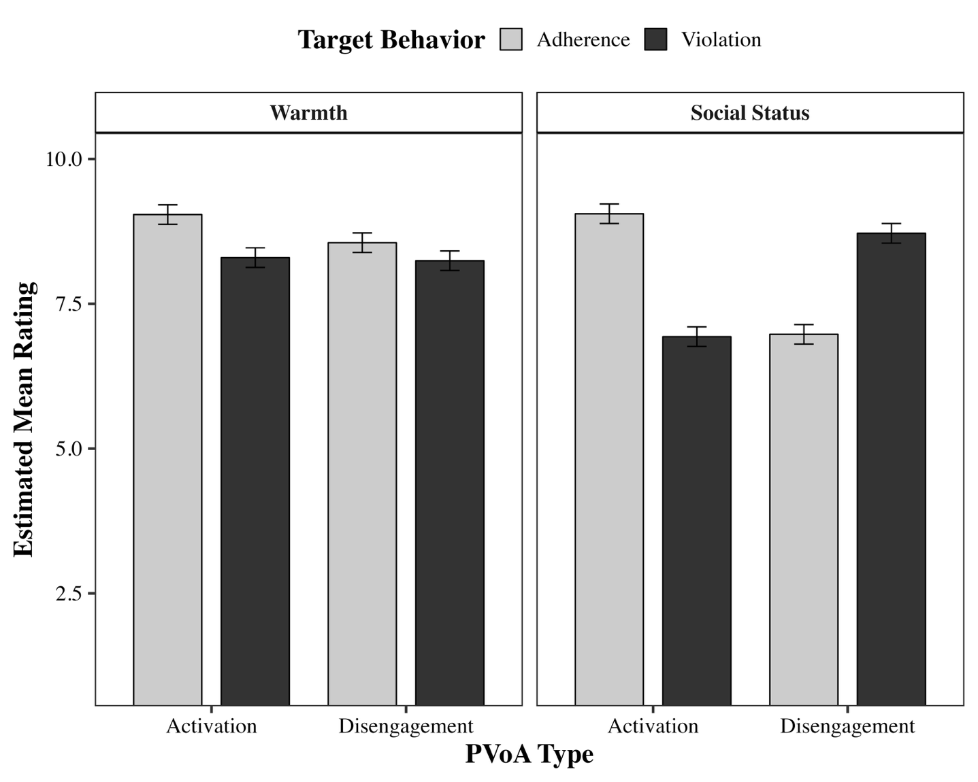
Note. Error bars show standard errors. PVoA = Prescriptive Views of Aging.

Figure S2
Pilot Study 2: Mean ratings of Target Profile Evaluation by Target Behavior and Evaluative Dimension.
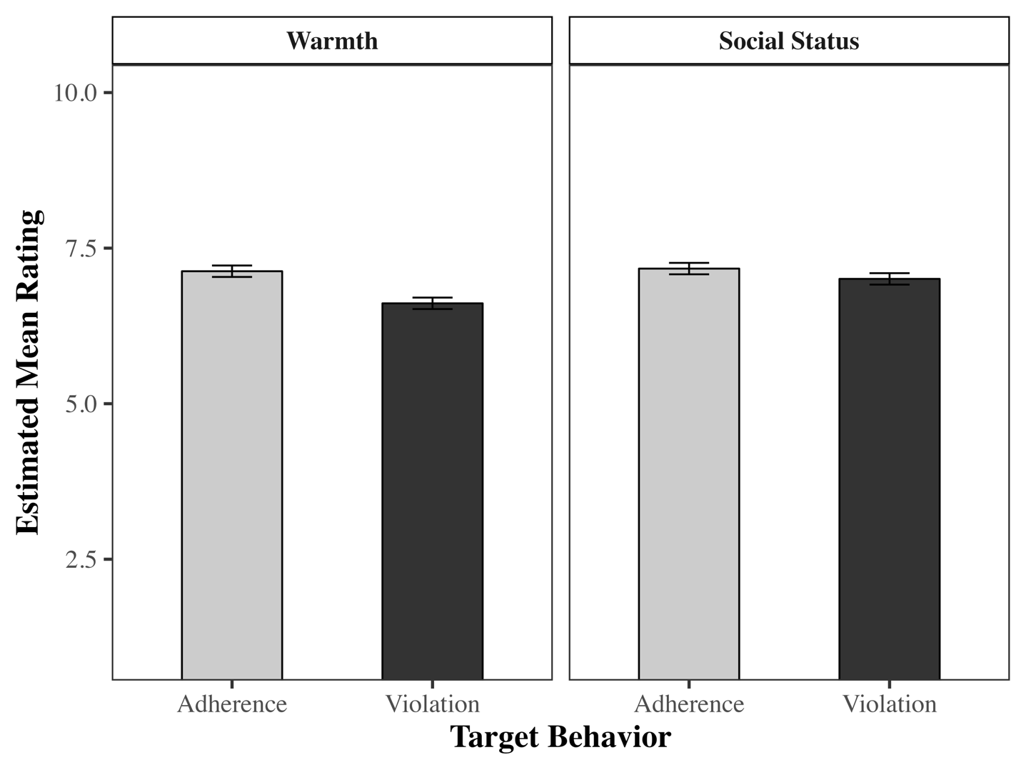
Note. Error bars show standard errors.

Appendix SA
Target Profiles Study 1
Disengagement Adherence
My name is Bernd, I’m 60 years old and work as a sound technician in a club. I’m starting to feel that I might be getting too old for this kind of job. That’s why I’d like to pass it on to someone for whom this environment feels more age-appropriate.
Activation Adherence
My name is Gerd, I’m 60 years old and work as an HR manager in a medium-sized company. I enjoy continuously engaging with new ideas and concepts for improving our work environment and processes. That’s why I’m happy to continue working in my profession for a few more years.
Disengagement Violation
My name is Martin, I’m 57 years old and work as a business consultant. Recently, I was offered the opportunity to step back from the demanding day-to-day work with clients due to my age and move into an internal administrative role. However, I don’t want that, as I handle the hustle and bustle just fine.
Activation Violation
My name is Mario, I’m 59 years old and work as a laboratory technician. I’m generally satisfied with my job. However, for some time now, I’ve been finding it increasingly difficult to concentrate and to manage the many different tasks all at once. That’s why I would like to be assigned fewer responsibilities and take things a bit more slowly.

Appendix SB
Target Profiles Pilot Study 2
Female Target Profiles
Female Adherence Set 1 (FA1)
My name is Inga, and I am 66 years old. I’m retiring this year and looking back on a long career as a bank clerk. I was offered the chance to continue working part-time, but I think it's important to make room for younger colleagues, so I will be leaving the company at the end of the year.
Female Adherence Set 2 (FA2)
My name is Inga, and I am 69 years old. I worked as an editor until a few years ago. Since retiring, I no longer take on any major social obligations. I leave the hustle and bustle to the younger generation and enjoy the peace and quiet of my private everyday life.
Female Violation Set 1 (FV1)
My name is Martha, I am 67 years old, and I work as a saleswoman in a medium-sized company. Although I am one of the oldest employees, I still really enjoy my job. I am not interested in retiring anytime soon.
Female Violation Set 2 (FV2)
My name is Martha, and I am 68 years old. I have held a position as a lawyer in a law firm for many years. Although I am past the statutory retirement age and there have already been discussions about who should take over my job, I do not want to stop yet and will continue to take on cases.
Male Target Profiles
Male Adherence Set 1 (MA1)
My name is Georg, and I am 69 years old. I worked as an editor until a few years ago. Since retiring, I no longer take on any major social obligations. I leave the hustle and bustle to the younger generation and enjoy the peace and quiet of my private everyday life.
Male Adherence Set 2 (MA2)
My name is Georg, and I am 66 years old. I’m retiring this year and looking back on a long career as a bank clerk. I was offered the chance to continue working part-time, but I think it's important to make room for younger colleagues, so I will be leaving the company at the end of the year.
Male Violation Set 1 (MV1)
My name is Frank, and I am 68 years old. I have held a position as a lawyer in a law firm for many years. Although I am past the statutory retirement age and there have already been discussions about who should take over my job, I do not want to stop yet and will continue to take on cases.
Male Violation Set 2 (MV2)
My name is Frank, I am 67 years old, and I work as a salesman in a medium-sized company. Although I am one of the oldest employees, I still really enjoy my job. I am not interested in retiring anytime soon.

